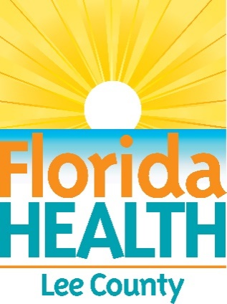
FOR IMMEDIATE RELEASE
July 24, 2025

Santa Rosa County Issues Water Quality Health Advisory

Advisory Issued for Navarre Beach

Contact:
Dede Barrett, PIO
PIO.CHD57@flhealth.gov
850-564-2263

Milton, Fla. — The Florida Department of Health in Santa Rosa County (DOH-Santa Rosa) has issued a water quality advisory for the following locations:
Navarre Beach
Navarre, FL 32566

Tests completed on Thursday, July 24, 2025, indicate that the water quality at Navarre Beach area at the public access 37A (at the west end of the beach before the National Seashore) and 40B (towards the east end of the beach close to Navarre Pier) does not meet the recreational water quality criteria for Enterococcus bacteria recommended by the Florida Department of Health.
DOH-Santa Rosa advises against any water-related activities at this location due to an increased risk of illness in swimmers. Sampling conducted during regular water quality monitoring showed that the level of bacteria exceeds the level established by state guidelines.
This advisory will continue until bacteria levels are below the accepted health level. Test results are available at FloridaHealth.gov/HealthyBeaches.

For more information, call 850-983-5275 or visit SantaRosa.FloridaHealth.gov.

###

About the Florida Department of Health
The Department, nationally accredited by the Public Health Accreditation Board, works to protect, promote, and improve the health of all people in Florida through integrated state, county, and community efforts.
Follow us on X at @HealthyFla and on Facebook. For more information about the Florida Department of Health, visit FloridaHealth.gov.

